A comparison of Dzyaloshinskii-Moriya interaction measurement techniques in Pt/Co/Ir thin films

Jeffrey Brock, Anni Cao, Avinash Chaurasiya, Pablo Domenichini, Katherine Nygren, and Pierre Vallobra

**Abstract:** We have performed an experimental study of the interfacial quality, static magnetization, and domain expansion properties in a sputter-deposited Pt/Co/Ir system, suspected to exhibit a large interfacial Dzyaloshinskii-Moriya interaction (DMI). By systematically varying the pressure at which the Ir layer was deposited from 3 to 25 mTorr, variations in the saturation magnetization and effective anisotropy constant were observed – suggesting a change in the quality of the Co/Ir interface. These observations were supported by low-angle X-ray reflectivity measurements, which demonstrated that the roughness of this interface increased ~ 25% over the range of deposition pressures. Kerr microscopy of magnetic domain growth demonstrated that below an applied out-of-plane field strength of 20 mT, domain expansion occurs within the creep regime of dynamics. Measurements of the asymmetry of domain expansion in the presence of a static in-plane and pulsed out-of-plane magnetic field indicated the presence of a DMI energy density of left-handed chirality (DDMI~-0.65 mJ/m2), and that the DDMI gently increased 9 % over the range of deposition pressures. However, Brillouin light scattering measurements indicated similar values and handedness of DMI energy density but an opposite trend with respect to Ir deposition pressure. These results indicate that the quality of the top ferromagnetic/heavy metal interface has a subtle effect on the DMI, and that two common measurement techniques can yield a discordance in DMI energy density trends.

**Introduction:**

As topologically protected swirling spin configurations, skyrmions show promise for non-volatile data storage with high-density and low-power consumption. A competition between the Dzyaloshinskii−Moriya interaction (DMI), Heisenberg interaction, dipolar interactions and Zeeman energy can result in different spin states. The interfacial Dzyaloshinskii−Moriya interaction (iDMI) is intimately related to the prospect of superior domain wall (DW) dynamics and the formation of magnetic skyrmions. Ever since it was discovered by Dzyaloshinskii and Moriya in 1958 and 1960[1],[2], DMI in structures with broken inversion symmetry has attracted significant scientific interest.

The DMI can be regarded as an effective field , which takes the form . and are neighboring spins at site 1 and site 2 and is the corresponding Dzyaloshinskii–Moriya vector. Except for the cases of bulk DMI found in bulk chiral magnets, DMI is generally attributed to the existence of spin-orbit coupling (SOC) and broken inversion symmetry at material interfaces will induce an iDMI. Considering the iDMI, can be written as[3] , where both and are unit vectors, pointing along the film normal and pointing from site 1 to site 2. For , the iDMI favours anticlockwise rotations from to , whereas the lower energy for clockwise magnetization rotation corresponds to . The spin canting favored by the DMI can promote the stabilization of a Néel-type domain wall over the otherwise magnetostatically-favorable Bloch wall[4],[5].

There are mainly three types of interfaces which promote strong DMI. The first and most common type is an interface between a ferromagnetic (FM) layer and a heavy metal (HM) layer with strong SOC. The relative position of the 3d states in the magnetic transition metal and the 5d states in the heavy metal is of great importance. The second type is a FM/oxide interface. A large charge transfer and a strong interfacial electric field are both induced at the oxide interface to compensate the small SOC of the atoms at the interface[6],[7],[8]. A large DMI was also found at a FM/graphene interface on account of the Rashba effect. In the case of the FM/HM interface, interface quality (i.e. roughness, degree of chemical intermixing) could be expected to play a role. This purported sensitivity of the iDMI to interface quality is supported by a plethora of reports of DMI in Pt/Co/Pt heterostructures[9],[10],[11], where the difference in interface quality between the top and bottom HM interfaces appears substantial enough to promote Néel walls despite the nominal symmetry of the material stacks.

Keeping this in mind, we chose to study a heterostructure featuring Co sandwiched between a Pt and Ir layer – motivated by reports that have suggested that the Co/Pt and Co/Ir interfaces have opposite-signed DMI vectors, such that when incorporated in a system with structural inversion asymmetry (i.e. the top FM/HM interface is different than the bottom one), a larger magnitude DMI may manifest[12],[13]. In order to assess the impact of the top FM/HM interface quality on the DMI, we have varied the sputtering process pressure at which the Ir layer was grown, which was inspired by other work on a Pt/Co/Pt system[14]. An increase in deposition pressure is expected to reduce the kinetic energy of the target atoms arriving at the substrate, potentially increasing the roughness while reducing the chemical intermixing at this interface[15]. Similar to the work of others[16], we have chosen to use two separate techniques to determine the DMI energy density of the Pt/Co/Ir samples – asymmetric domain expansion measurements (performed using Kerr microscopy) and measurements of the non-reciprocity of left- and right-handed spin waves using Brillouin light scattering spectroscopy.

**Experimental Details**

Films of the structure SiO2 (thermal oxide) (300 nm)/ Ta(5 nm)/ Pt(3 nm)/ Co(0.8 nm)/ Ir(1 nm)/ Ta(2 nm) were grown using the dc magnetron sputtering technique. All layers were deposited using an Ar process gas pressure of 3 mTorr at 50 W power, save for the Ir layer which was deposited at deposition pressures (PIr) of 3, 7.5, 16.5, 21, and 25.5 mTorr. Low-angle X-ray reflectivity measurements were performed using a monochromatic Cu-Kα1 source. The static magnetic properties were assessed at room temperature using a superconducting quantum interference device vibrating sample magnetometer (SQUID VSM). The domain expansion measurements were performed using differential subtraction Kerr microscopy, under the influence of both out-of-plane and in-plane magnetic fields. Brillouin light scattering (BLS) experiments used a Sandercock-style six-pass Fabry-Perot interferometer in the conventional backscattering laser geometry. Measurements were performed in the Damon-Eshbach (surface wave) sample geometry, where the magnetic field is applied in the sample plane and perpendicular to the spin wave propagation direction.

**Results and Discussion**

**A. X-ray characterization**

A typical rocking curve measurement for the PIr = 3 mTorr sample is shown in Figure 1(a). This rocking curve measurement was collected about the first Kiessig fringe determined from low-angle X-ray reflectivity measurements (see inset of Figure 1(a)). By taking the ratio of the specular portion of the reflection over the diffuse portion, a metric proportional to the roughness of all interfaces in the structure can be calculated[17]. The results of this calculation for each PIr is shown in Figure 1(b). From Figure 1(b), an increase in the roughness of the samples as PIr increases is noted – a trend that may be attributed to the larger Ir grains that could be expected to form at higher deposition pressures.[18] While the measurements shown in Figure 1(b) indicate that the roughness increases with PIr, it says nothing as to the degree of chemical intermixing at the interfaces. In order to further probe the changing interfacial quality of the Pt/Co/Ir structures, an algorithmic fitting of the X-ray reflectivity measurements was performed using GenX[19], from which a σ parameter (representing the quadrature sum of the roughness and chemical intermixing of the interfaces) can be calculated. From the extracted σ parameter shown in Figure 1(c), a very subtle trend of decrease in σ as PIr increases is observed. However, since we cannot fully distinguish between the contributions of roughness and intermixing at the interface, we cannot say with certainty that the degree of chemical intermixing has decreased with increased PIr from X-ray measurements alone.

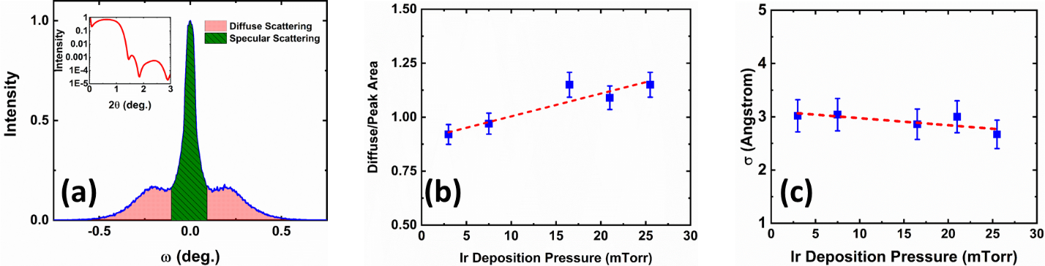

Figure : (a) Rocking curve of the PIr = 3 mTorr sample, collected about the first Kiessig fringe of the low-angle X-ray reflectivity curve of the same sample (inset). (b) The ratio of the integrated diffuse area of the rocking curve over the integrated area of the specular portion of the rocking curve as a function of Ir deposition pressure. (c) The σ parameter extracted from algorithmic fitting of the low-angle X-ray reflectivity curve (representing the quadrature sum of the roughness and chemical intermixing components) as a function of Ir deposition pressure.

**B. Static magnetic measurements**

The static hysteresis loops at room temperature for the out-of-plane measurement orientation of the Pt/Co/Ir samples are shown in Figure 2(a). From this figure, we can note that as the pressure at which the Ir layer is deposited increases, the coercive field increases dramatically, and the saturation magnetization (MS) slightly increases as well. The increase in the coercive field with PIr can be attributed to the increased roughness[20] suggested by the X-ray data shown in Figure 1(b), as roughness will act to pin reversal domains as they expand, as has been seen in other systems where the top FM/HM interface was modified relative to the bottom. As the volumetric saturation magnetization is calculated using the nominally-deposited Co thickness (0.8 nm for all samples), the slight increase in saturation magnetization suggests that a chemically-purer Co layer is formed. From in-plane hysteresis loops (not shown), the anisotropy field (HK) was determined and found to vary non-monotonically at about 2 T. The MS and μ0HK as function of PIr are shown in Fig. 2(b) and 2(c), respectively. Given the non-monotonic behavior of HK as a function of PIr, these results suggest that the bottom HM/FM interface is more influential on the anisotropy of the film, as has been suggested by other studies[21].

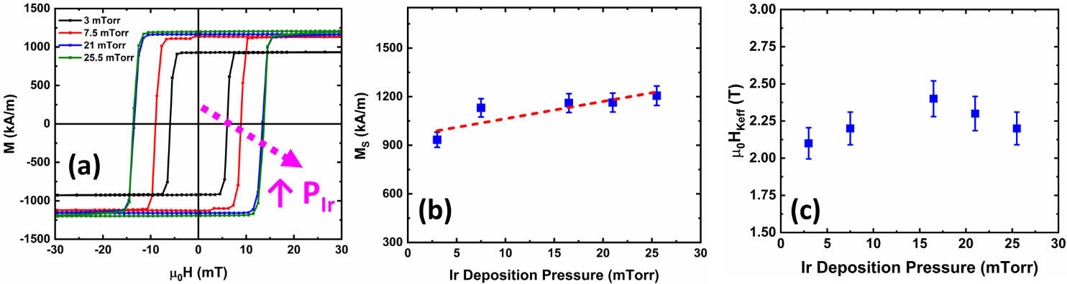

Figure : (a) Out-of-plane hysteresis loops, collected at room temperature for each Ir deposition pressure. (b) Saturation magnetization as a function of Ir deposition pressure. (c) Anisotropy field as a function of Ir deposition pressure determined from in-plane hysteresis loops.

**C. Creep-scaling law measurements**

The dynamics of magnetic bubble domain growth can be categorized in to different regimes based on how the velocity of expansion (V) changes with respect to an applied magnetic field (H).[22],[23] For weak magnetic fields, domain expansion occurs within the so-called creep regime, where the magnetic spins are strongly anchored, and growth occurs via thermally-activated, field assisted hopping between strong pinning sites. In the creep regime, the velocity of domain expansion can be modeled as:

(1)

Where is a velocity scaling parameter and α is a constant related to the energy barrier to domain growth of the system. As the field is increased, the system goes through a magnetic depinning until it reaches a linear relationship with the field, and Eq. 1 is no longer valid (the flow regime).

To assess the growth regime probed in the Pt/Co/Ir samples, one of the most common techniques, polar Magneto-optical Kerr Effect (pMOKE), was used. In order to calculate the velocities, a quasi-static image acquisition technique was used. This consists taking images of the domains after applying a pulsed magnetic field perpendicular to the sample plane of field strengths between 100 Oe and 200 Oe. To determine the speed, the forward distance (D) was determined, as shown in Figure 3(a), and with the known the pulse time (T), the velocity is given by V = D/T. Figure 3(b) shows how a domain grows in the PIr = 3 mTorr sample after sequential out-of-plane pulses were applied. After obtaining the speed of domain expansion at several different magnetic field strengths, the law of creep velocities was checked by the following linearization[24]:

(2)

Where A = α and B = ln (). From the results shown in Figure 3(c), the V(H) data of the Pt/Co/Ir system fits very well with this linearization. Additionally, it was found that the velocity in the creep regime decreases as PIr increases. This may be due to the change in roughness of the Ir layer[25], and is corroborated by the increase in coercive force with PIr seen in Fig. 2(a). These measurements indicate that for out-of-plane magnetic fields less than 200 Oe in strength, domain expansion occurs within the creep regime. This puts our work in a similar context as other reports in which the DMI was assessed using domain growth imaging-based techniques.9,10,13

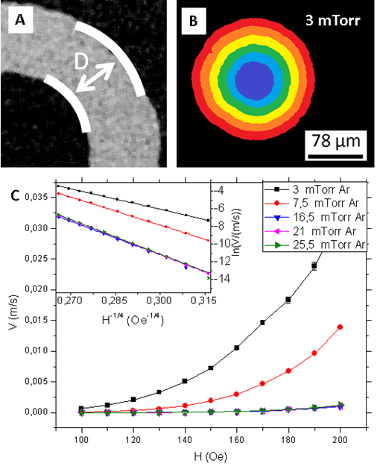

*Figure 3: (a) Progression of a moving domain wall and a demonstration of how the displacement of the domain wall after each pulse was determined. (b) Domain growth of the PIr = 3 mTorr sample between successive out-of-sample-plane field pulses are applied. The blue color indicates the initial domain, and the red one the end. (c) Domain expansion speed as a function of the field for several PIr. The inset shows the linear adjustment, signifying that the system is in the regime of creep.*

**D. Asymmetric domain growth characterization**

In order to probe the presence of DMI in our samples, one available technique involves the use of Kerr microscopy, performed under the influence of a static in-plane field and a pulsed out-of-plane field. The principle of this measurement relies on the idea that a sufficiently-strong DMI can transform Bloch domain walls to Néel domain walls. With zero in-plane applied field, the energy density of a Néel wall is symmetric around the domain wall. However, in the presence of a nonzero in-plane magnetic field, a difference in Zeeman energy between the left and right side of the domain can develop, which can manifest as a growth asymmetry when an out-of-plane magnetic field is applied10,11,[26]. Our procedure was as follows: First, a permanent magnet was used to nucleate a small circular domain within the field of view of the Kerr microscope. Next, a static in-plane field was applied, and a background image was collected and subtracted from the view. Finally, an out-of-plane field pulse of known duration (3 ms) and known field strength (~20 mT) was applied to allow the domain to expand and demonstrate any energy asymmetry (Figure 4). The velocity of domain expansion of the left (down to up) versus the right (up to down) side of the wall could be calculated after determining the displacement that occurred during the pulse duration. An example of this data is shown in Figure 5(a). From the velocity data shown in Figure 5(a), each side of the domain

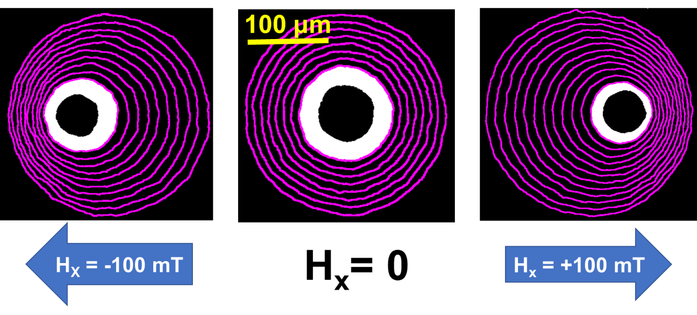

Figure : Magnetic domain expansion measurements collected in a variety of in-plane magnetic fields using Kerr microscopy. The magenta circles represent the expanded position of the domain after subsequent 3 ms long 20 mT out-of-plane field pulses were applied out of the sample plane.

exhibits a respective minimum in velocity depending on the direction in which the in-plane magnetic field is applied. By calculating the field at which this minimum in velocity occurs (μ0HDMI), the DMI energy density (DDMI) for each sample can be calculated using the expression:

(3)

By extracting the μ0HDMI value from each sample’s velocity vs. in-plane field profile, assuming an exchange stiffness (A) of 10 pJ/m (which is commonly employed for Pt/Co systems), and calculating the effective anisotropy constant (K­eff) using the expression Keff = μ0HKMS/2, a DDMI value can be obtained using Eq. 3. The result of this calculation for each PIr is shown in Figure 5(b). From Figure 5(b), we can infer that DDMI increases in magnitude very minutely with PIr – an effect that may be attributed to the changing quality of the Co/Ir interface that occurs concomitant to an increase in the pressure at which Ir is deposited.

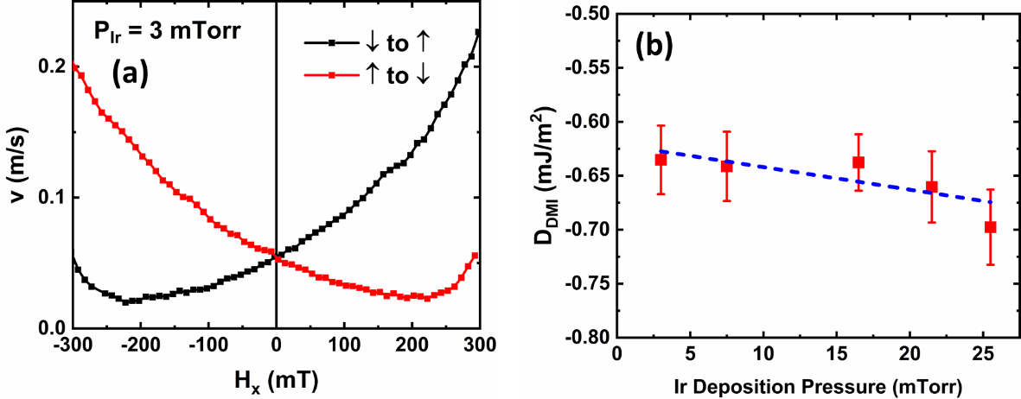

Figure : (a) Expansion velocity of the up-to-down (right) and down-to-up (left) collected using the same protocol detailed in the Fig. 4 caption for the sample grown with PIr = 3 mTorr. (b) The DMI energy density as a function of Ir deposition pressure.

**E. BLS Measurements**

Brillouin light scattering is an inelastic light scattering process where the total momentum is conserved in the plane of the thin film. As a result, the Stokes (anti-Stokes) peaks in BLS spectra correspond to the creation (annihilation) of magnons with momentum , where is the wavelength of the incident laser (532 nm in our case) and refers to the angle between the incident laser and the sample normal.

Typical BLS spectra recorded at higher wave vector (*k* = 2.04 × 107 rad/m) for different samples with varying Ir deposition pressure are presented in Fig. 6(a). To obtain Δ*f*, the Stokes (-*f* ) and anti-Stokes (+*f* ) magnon peaks were fit with a Lorentzian function, and then flipped about *f* = 0 for a direct comparison between the peak frequency locations. The frequency asymmetry (Δ*f* ) is shown Fig. 6(b) as a function of spin wave vector *k* for three different samples. This data was then fit with the following linear correlation equation, from which the value of has been extracted.

(4)

We use g = 2.0 for finding and Ms = 1000 kA/m in the linear fit. Figure 6(c) shows the variation of DDMI as a function of Ir deposition pressure. It is evident that the magnitude of DDMI decreases slightly with increase of Ir deposition pressure – an opposite trend to what was observed from the domain growth asymmetry measurements shown in Fig. 5(b), but that the magnitude of DDMI values returned by the two techniques are similar. Reasons for this wide difference in trends gleaned from Kerr imaging and BLS measurements may include the fact that the BLS calculations do not account for surface anisotropy and the corresponding pinning that may be present in our samples, a systematic frequency shift in the BLS data from the simulated rather than actual polarization change to the applied magnetic field, as well as the interaction length scales that the two techniques probe and a potential change in the applicability of the creep-scaling law in the presence of an in-plane magnetic field14, 16, [27]. In principle, while the two techniques should complement each other, data for the Pt/Co/Ir system indicates that there is an uncertainty inherent to determining trends in DMI samples that are so similar to one another.

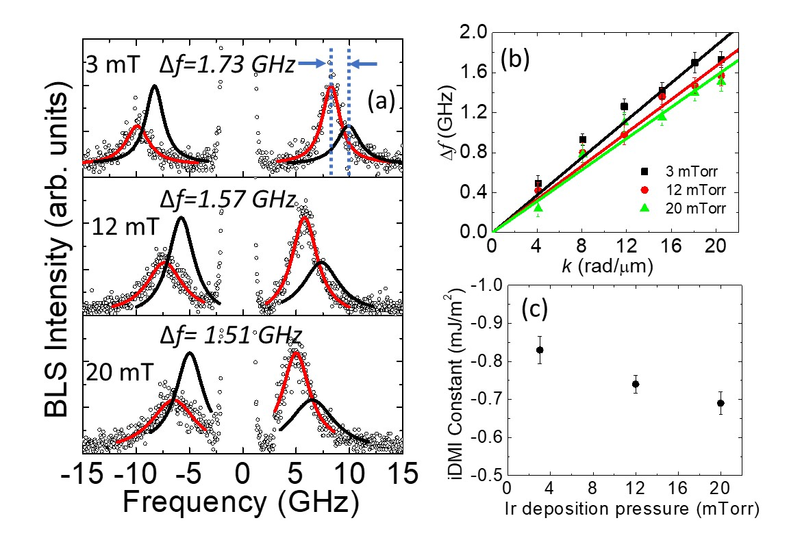

3 mTorr

12 mTorr

20 mTorr

Figure : (a) Representative BLS spectra measured at wave vector k = 20.4 rad/µm, H = 4.5 kOe for the Pt/Co(1.6 nm)/Ir sample for two counter propagating directions. The spectrum corresponding to a particular PIr is indicated by mentioning its v value in each panel. The solid curve is the fit using a Lorentzian function. (b) Plot of Δf vs k for Pt/Co(1.6 nm)/Ir samples with various values of Ir deposition pressure. Symbols represent the experimental data points and solid lines are the fit using Eq. **(1).** (c) Variation of DMI constant with Ir deposition pressure.

**Conclusion**

In summary, we have performed an experimental study of the interfacial quality, magnetic properties, and Dzyaloshinskii-Moriya interaction (DMI) in thin films featuring a Pt/Co/Ir motif. By changing the pressure at which the Ir layer is deposited, the quality of the Co/Ir interface, defined both in terms of the roughness and chemical intermixing at this interface, can be changed slightly. This changing quality of the Co/Ir interface leads to a dramatic increase in the coercive field of the samples and a more gradual increase in the saturation magnetization with the pressure at which the Ir layer was deposited. Indirect measurements of the DMI via domain expansion in an energy-symmetry breaking in-plane magnetic field demonstrated a modest increase in the magnitude of the DMI energy density with an increase in Ir deposition pressure, while the BLS results indicate a slight decrease in the magnitude of the DMI value with PIr. The discording trends in DMI energy density as a function of Ir deposition pressure yielded by these two techniques indicates that making a direct comparison between them remains a challenge – likely due to the differing interaction scales of the two techniques. Furthermore, our findings indicate that improving the quality of the top ferromagnetic/heavy metal interface has but a muted impact on the DMI strength of the system.

**Acknowledgements**

We gratefully acknowledge support from the IEEE Magnetics Society Summer School 2018 Student-led Project Competition.

**Individual Contributions**

Jeffrey Brock – Fabricated the samples, performed the X-ray characterization, performed the asymmetric domain growth experiments, and assisted in preparing the manuscript.

Anni Cao – Contributed to the formulation of the project and preparing the manuscript.

Avinash Chaurasiya – Performed the Brillouin light scattering measurements and assisted with preparing the manuscript.

Pablo Domenichini – Performed the creep-scaling law measurements and calculations and assisted in preparing the manuscript.

Katherine Nygren – Contributed to the formulation of the project and preparing the manuscript.

Pierre Vallobra – Performed static characterization and assisted in preparing the manuscript.

**References**

1. T. Moriya, Phys. Rev. 120, 91 (1961).
2. I. Dzyaloshinskii, J. Phys. Chem. Solids 4, 241 (1958).
3. H. Yang, A. Thiaville, S. Rohart, A. Fert, M. Chshiev, Phys. Rev. Lett. 115, 267210 (2015).
4. A. Thiaville, S. Rohart, E. Jue, V. Cros, and A. Fert, Europhys. Lett. 100, 57002 (2012).
5. M. Heide, G. Bihlmayer, and S. Blugel, Phys. Rev. B 78, 140403(R) (2008).
6. A. Belabbes, G. Bihlmayer, S. Blügel, A. Manchon, Sci. Rep. 6, 24634 (2016).
7. O. Boulle, J. Vogel, H. Yang, S. Pizzini, D. de S. Chaves, A. Locatelli, T. O. Menteş, A. Sala, L. D. Buda-Prejbeanu, O. Klein, M. Belmeguenai, Y. Roussigné, A. Stashkevich, S. M. Chérif, L. Aballe, M. Foerster, M. Chshiev, S. Auffret, I. M. Miron, G. Gaudin, Nat. Nanotechnol. 11, 449 (2016).
8. A. Fert, N. Reyren, V. Cros, Nat. Rev. Mater. 2, 1038 (2017).
9. A.W.J. Wells, P.M. Shepley, C.H. Marrows, and T.A. Moore, Phys. Rev. B 95, 054428 (2017).
10. S.G. Je, D.H. Kim, S.C. Yoo, B.C. Min, K.J. Lee, and S.B. Choe, Phys. Rev. B 88, 214401 (2013).
11. G. Chen, T. Ma, A.T. N’Diaye, H. Kwon, C. Won, Y. Wu, and A.K. Schmid, Nat. Commun. 4, 2671 (2013).
12. C. Moreau Luchaire, C. Moutafis, N. Reyren, J. Sampaio, C.A.F. Vaz, N. Van Horne, K. Bouzehouane, K. Garvia, C. Deranlot, P. Warnicke, P. Wohuter, J.M. George, M. Weigan, J. Raabe, V. Cros, and A. Fert, Nat. Nano 11, 444 (2016).
13. A. Hrabec, N.A. Porter, A. Wells, M.J. Benitez, G. Burnell, S. McVitie, D. McGrouther, T.A. Moore, and C.H. Marrows, Phys. Rev. B 90, 020402(R) (2014).
14. R. Lavrijsen, D.M.F. Hartmann, A. van den Brink, Y. Yin, B. Barcones, R.A. Duine, M.A. Verheijen, H.J.M. Swagten, and B. Koopmans, Phys. Rev. B 91, 104414 (2015).
15. G.A. Bertero and R. Sinclair, J. Magn. Magn. Mater. 134, 173 (1994).
16. R. Soucalle, M. Belmeguenai, J. Torrejon, J.V. Kim, T. Devolder, Y. Roussigne, S.M. Cherif, A.A. Stashkevich, M. Hayashi, and J.P. Adam, Phys. Rev. B. 94, 104431 (2016).
17. D. E. Savage, J. Kleiner, N. Schimke, Y.-H. Phang, T. Jankowski, J. Jacobs, R. Kariotis, and M. G. Lagally, J. Appl. Phys. 69, 1411 (1991).
18. K. Srinivas, M. Manivel Raja, D.V. Sridhara Rao, and S.V. Kamat, Thin Solid Films 558, 349 (2014).
19. M. Bjork and G. Andersson, J. Appl. Cryst. 40, 1174 (2007).
20. D. Aurongzeb, K. Bhargava Ram, and L. Menon, Appl. Phys. Lett. 87, 172509 (2005).
21. S. Bandiera, R.C. Sousa, B. Rodmacq, and B. Dieny, IEEE Mag. Lett. 2, 3000504 (2011).
22. P. J. Metaxa, J.P. Jamet, A. Mougin, M. Cormier, J. Ferre, V. Baltz, B. Rodmacq, B. Dieny, and R.L. Stamps, Phys. Rev. Lett. 99, 217208 (2007).
23. V. Jeudy, A. Mougin, S. Bustingorry, W. Wavero Torres, J. Gorchon, A.B. Kolton, A. Lemaitre, and J.P. Jamet, Phys. Rev. Lett. 117, 057201 (2016).
24. C.P. Quinteros, S. Bustingorry, J. Curiale, and M. Granada, Appl. Phys. Lett. 112, 262402 (2018).
25. P.M. Shepley, H. Tunnicliffe, K. Shahbazi, G. Burnell, and T.A. Moore, Phys. Rev. B 97, 134417 (2018).
26. E. Jue, C.K. Safeer, M. Drouard, A. Lopez, P. Balint, L. Buda-Prejbeanu, O. Boulle, S. Auffret, A. Schuhl, A. Manchon, I.M. Miron, and G. Gaudin, Nature Mat. 15, 272 (2016).
27. S. Lemerle, J. Fero, C. Chappert, V. Mathet, T. Giamarchi, and P. Le Doussal, PRB 80, 849 (1998).